MEET OUR HONORARY WALK CHAIRS, THE FAMILY OF DANA LYNN RANEY

This year, we are honored to have the Family of Dana Lynn Raney as our honorary Omaha Walk Chairs. We are so very grateful for the tremendous support Dana’s family and all the members of Team Dana have shown our Walk and our agency through the years. Their Walk team membership is in the hundreds.

Dana, herself, attended the Walks before her passing. Dana was ALS in the Heartland’s youngest patient to date, only 23 years old when she first came to us. Below, David (Dana’s father) and Linda (Dana’s mother) share their stories.

DAVID’S STORY

On April 13, 2014, at 1:35 PM, surrounded by a grieving, loving family, our daughter, Dana Lynn Raney lost her battle with Amyotrophic Lateral Sclerosis (ALS). Dana fought hard to stay alive; she opted for a feeding tube and a ventilator so she could give her two nieces as much love as she could with what time she had left.
Thanks to some very special caregivers, her mother Linda and I were able to take care of her at home. It was not an easy task; it took 24-7 around-the-clock vigilance and many nights with little or no sleep. Dana was our daughter and we would do it all again if it would bring her back.
Dana was a strong believer in her faith; when we would question God, she would set us straight in a hurry. She told me hope for a cure and God were the only things she had to hold onto.
I am not a speaker nor a writer but we need to let people know how horrible this disease is. We watched Dana lose her ability walk, her ability to use her arms, her ability to talk, her ability to swallow, and her ability to breath without the aid of a ventilator. Dana talked to us with a computer and when she was unable to use that, we used a letter board to communicate. ALS takes everything from you except pain and the use of your brain. Dana laid in bed unable to move, feeling everything, knowing everything and unable to do anything about it.
Dana hated the wheelchair, she hated the lift and she hated ALS. She once spelled out to me on the letter board "I need a friend,” and she often told us “I need Leann” (her sister living in Virginia).
That is why I am speaking out today, to help bring awareness to ALS.
We need a cure so no one else ever has to hold a loved one in their arms as they die from this disease as we did on that April day. This is something I pray for every day.
Dana fought to the end and beyond. With the help of her sister-in-law she donated her body to the University of Kansas Medical Center for ALS research.
She gave us her motto for Team Dana, LOVE STRONG, and that is exactly what she did. So I say to all of you today, HUG THOSE YOU LOVE, and don't be embarrassed, be thankful that they can hug you back. I would have given anything for a hug from Dana.
Let's find a cure and LOVE STRONG!

Dana’s Father,
David Raney

LINDA’S STORY

Where do I begin? My baby girl is gone. She was the youngest of our three children and our youngest daughter. The most horrible, terrible, debilitating, mean disease out there took our beautiful and caring daughter, Dana Lynn Raney, who was named after her father, my husband, David Lynn Raney, from us. That disease was Amyotrophic Lateral Sclerosis (known as ALS, Lou Gehrig's Disease).
Dana, was only 26 years old when she was taken from us. It was the worst moment in my life. It is beyond words how to explain how her father and I felt to lose a child. Her father and I, along with her older brother, Eddie, and her older sister, Leann, and other family members, friends, and priests were with us when she left us in our home in Alexandria, Nebraska. We all miss her so much and our two beautiful granddaughters, Gabrielle Jeannette and Karina Marie, lost a very special aunt, who loved them beyond words. Our hearts are broken forever with the loss of our beautiful, caring, energetic, and special Dana. Dana had a smile for everyone and would help anyone in need.
ALS, this horrible disease, took everything away from her; at the end of her life, she only had her beautiful eyes. Dana suffered beyond words. Each and every day for 2 years, this monster of a disease took something from our daughter, we can never know the pain and helplessness she felt. Her father and I cried every day and prayed constantly to find a cure for this mean and evil disease. Dana cried so much and we had to wipe her eyes, which tears a person apart to have to do for your child. We need a CURE for ALS. Those beautiful eyes of our daughter are forever etched in my mind. Dana desperately wanted her life back that she loved so much.
Dana was not ready to leave this earth, she had so much more to give in this life. Everyone that knew Dana always knew she was thinking of others even as she lay in bed for two years on a ventilator and a feeding tube. She wanted to help others so she donated her body to science to help find a cure for this horrible disease known as ALS. Dana donated her body to the University of Kansas Medical Center.
Remember those three letters, ALS. It means a death sentence. I hate to say those two words but it is exactly that. It doesn't discriminate. It doesn't care how old you are. It doesn't care about you at all. It's an evil destructive disease that needs to have more research done to find a cure.
We never thought in a million years that this horrible disease would ever affect our family, especially our young daughter, Dana. Dana was very athletic, she played sports and loved volleyball. She also loved to hunt, fish and take pictures. Dana was our world and we wanted so much for her. I even asked God many times a day from the time she was diagnosed till her last breath to take me instead. I lived a great life and I wanted my daughter, my Dana, to have what I had. Dana and I talked a lot and she would always say, “Mom, I don't want you to have this or anyone else, but be ready: the worst isn't here yet. I don't want this disease, but I don't want anyone else to have it. I hate this disease, but since I can't do anything about it, I want to donate my body to science and maybe someday there will be a cure and I will know I helped someone even if I'm gone." Dana was a very special young woman and I was proud to call her my daughter. She was so brave and I told her so many times, “You are and always will be the bravest person I will ever know.” Our daughter was a fighter to the end and to hold her in our arms as our beautiful daughter slipped away from us is, again, beyond words.
I wish every day to have her back. I miss her smile; everyone loved that smile and her voice. I wish for just one more time to hear her voice and see her smile. I miss so much about my daughter. Part of my world is lost, but my family helps me so much. I don't know what I would have done without my husband; he is my rock. We have cried so much to have our girl back. That was the hardest times talking about her leaving all of us, especially to leave her nieces, Gabrielle and Karina; she called them Gabs and Sissy. They were her life, that is why she chose the ventilator and feeding tube, she wanted to see them as long as she could. She loved them with all her heart and she cried so much, wanting to stay here. She always talked about what we were to give them, so as they grow up they will always be receiving things from their Aunt Dana.
Dana, was a young 22-year-old young woman, full of life who went off to college at Wayne State College in Wayne, Nebraska and graduated in three years in 2009 with a Bachelor’s of Science degree and was so impressed with herself in accomplishing that. Dana then went to the America World Adoption Agency in McLean, Virginia to do her internship. She loved her internship and also she got to live with her sister, Leann, and her brother-in-law, Ryan, during this time. Dana then returned to Nebraska. She was excited to start her job in Lincoln at Home Instead. Dana was then able to get the job she loved at Community Action Partnership for Lancaster and Saunders Counties in Lincoln.
Dana loved dancing. She would dance anywhere, at any time, with anyone. She regularly attending line dancing at the Pla Mor Ballroom in Lincoln, Nebraska. Dana also loved to travel with friends and family. She was always up for an adventure!
Dana's life was turned around when she received the most devastating medical news anyone could receive: ALS. She cried and cried. We could only hold her and hold her. Every day was a struggle for Dana. She was so special to us, I resigned from my job so I could care for her at home. I would do it over again and again, I never regretted doing it. I was home 24/7 to help her. Our daughter did not deserve to have this evil and mean disease, she deserved more, so much more, so please help any way you can to help everyone in this world to have some hope for a cure of this monster of a disease or to slow the progression down. We need something, so please donate. Our daughter, Dana had a motto," LOVE STRONG". We live by her words every day. Help us "DEFEAT ALS".
Every day I wear a necklace that bears Dana’s motto, Love Strong. It was a gift from my niece, Julie Brockman. David and I always wear our Team Dana bracelets every day to get the word out about curing ALS.

Dana's Mother,
Linda Raney

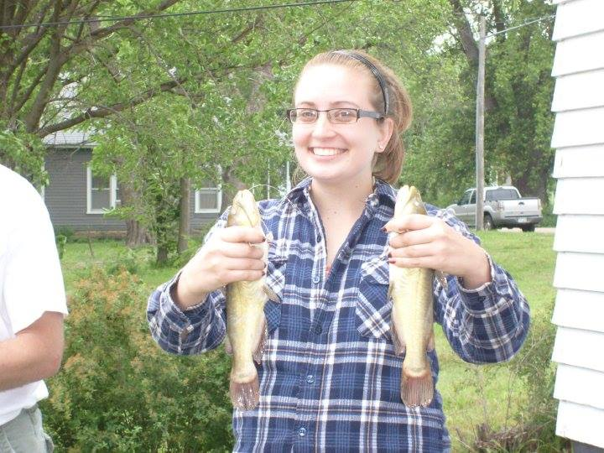
Dana Lynn Raney

